ORANGE BANK OF BOTSWANA SYSTEM
User Registration and Customer Type Selection
1. Introduction
The user registration feature for the Orange Bank of Botswana is designed to be simple, secure, and efficient. One of the key steps in this process is choosing the customer type. This step customizes the registration form to match the needs of either an Individual or a Company. By doing this, the system only asks for information that is relevant to each type of customer, making the onboarding process easier and more accurate.

2. Customer Type Selection
When a new user opens the registration portal, the first thing they must do is choose what kind of customer they are. This choice determines what type of registration form they will receive. The two options are:
- Individual Customer – for everyday people who want personal banking services like savings accounts, personal loans, or cards.
- Company Customer – for businesses or organizations that need corporate banking services such as business accounts, payroll, or merchant services.
This step is important because it prevents individuals from being asked for business information, and businesses from being asked for personal data
Sign Up
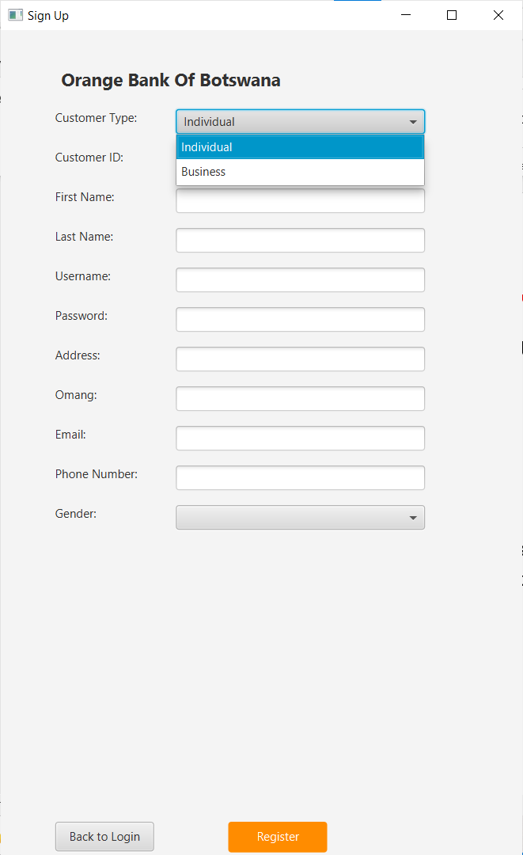
Login
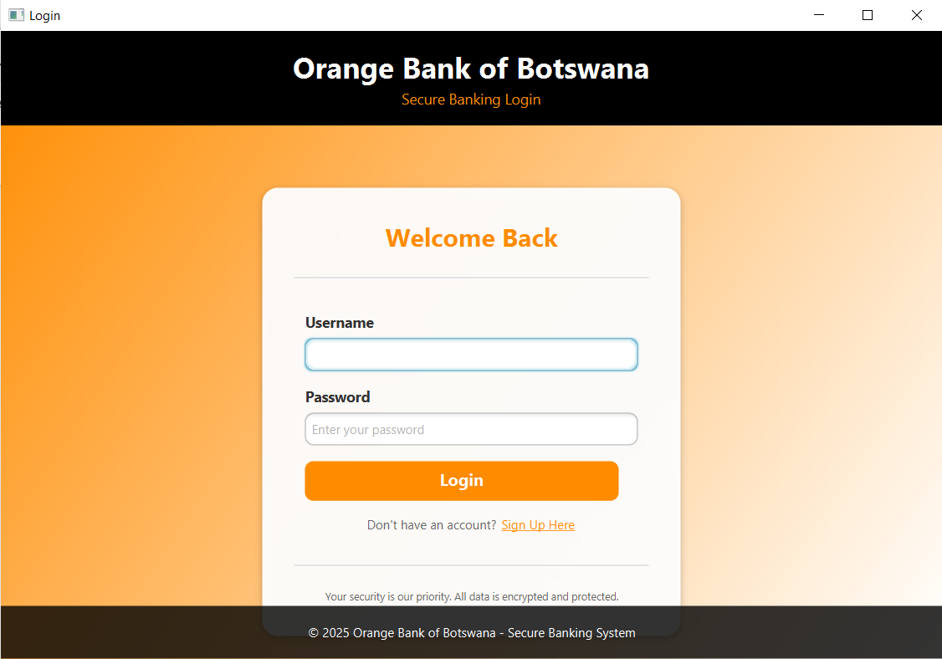

User Dashboard And Account Management
1. Introduction
After logging in, users of the Orange Bank of Botswana system are welcomed with a secure, personalized dashboard. This dashboard serves as the main control center where customers can quickly view their financial information and access important banking features. The design shown in the example for user Eric Stegling is clean, simple, and built to help users manage their money with ease.

2. Dashboard Layout and Personalization
The dashboard is organized in a way that makes information easy to find and understand.
- Branding And User Info
At the top, the Orange Bank of Botswana logo is displayed, followed by the text “Logged in as: Eric Stegling.” This helps users confirm they are signed into the correct account.
- Welcome Message
A friendly greeting such as “Welcome, Eric Stegling!” adds a personal touch and enhances the user experience.

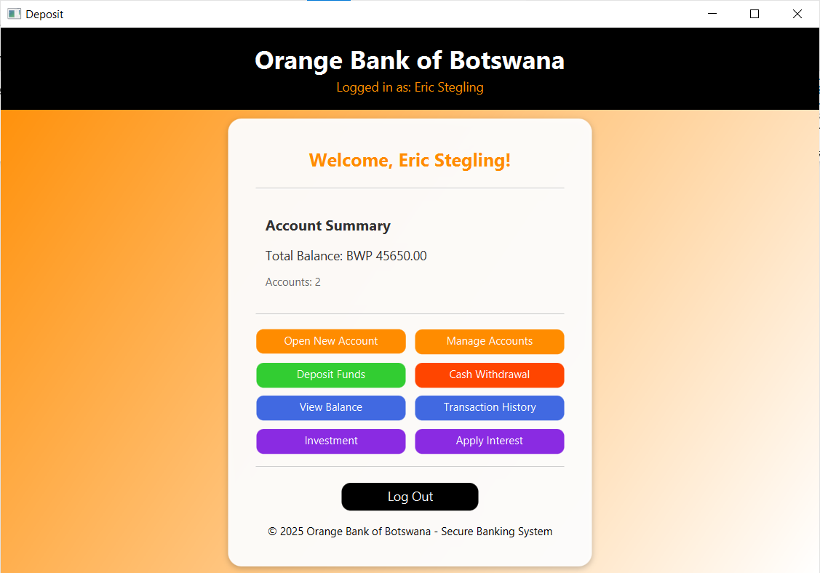

3. Key Features and Functions
The dashboard is divided into sections that help users access banking tools quickly.
A. Account Summary
This section shows a quick overview of the user’s financial status.
- Total Balance: Displays the combined balance of all accounts (e.g., BWP 45,000.00).
- Number of Accounts: Shows how many accounts the user has (e.g., 1 account).
This gives users a simple snapshot of their finances without needing to open multiple pages.
B. Banking Operations Menu
This menu contains all the main banking actions, clearly labeled for easy navigation:
- Open New Account – Apply for a new current, savings, or other account type.
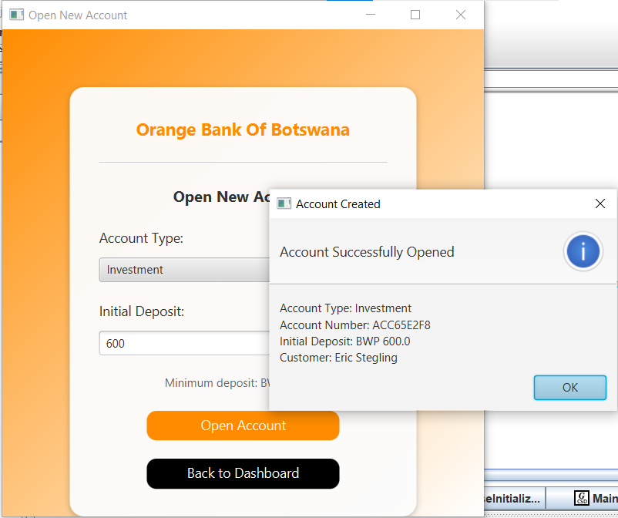

- Manage Accounts – View or update existing accounts.
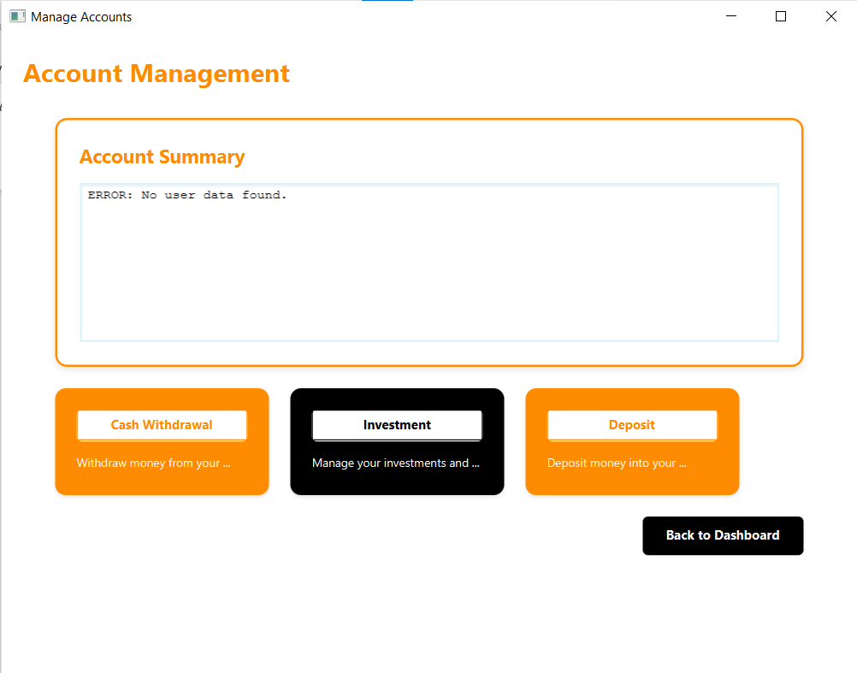
- Deposit Funds – Add money to an account.
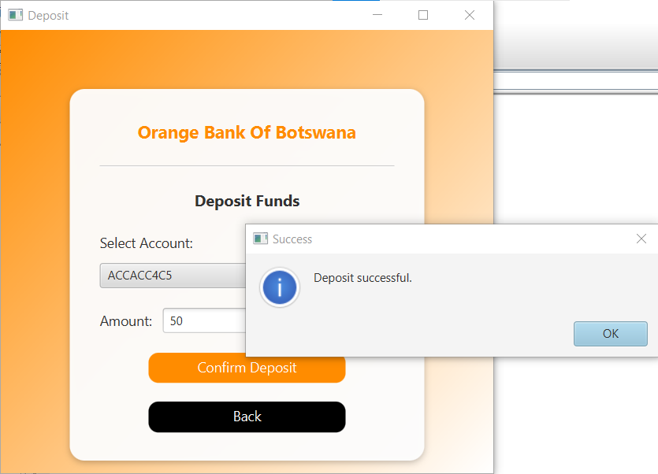
- Cash Withdrawal – Start the process of withdrawing money.
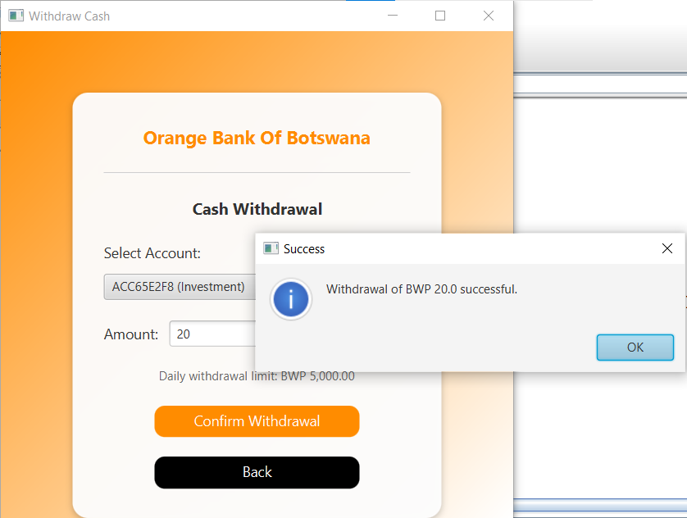
- View Balance – Check detailed balances for each account.
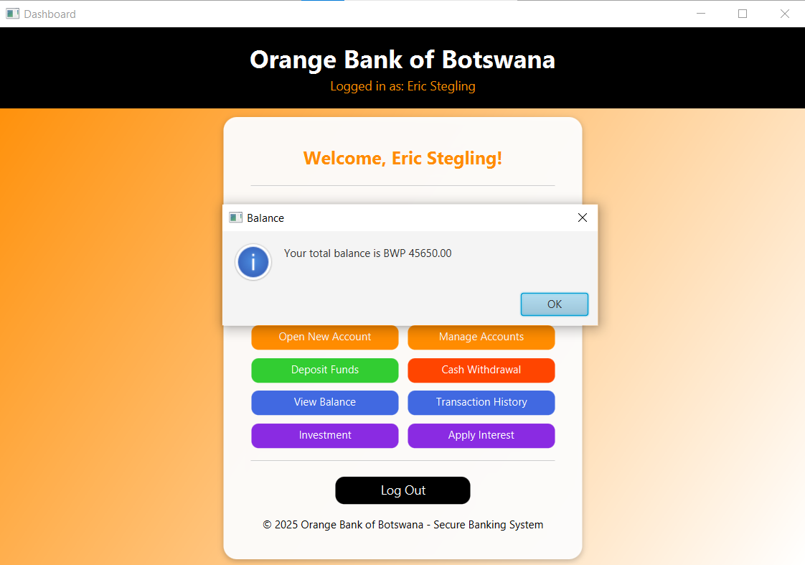
- Transaction History – View past deposits, withdrawals, and transfers.
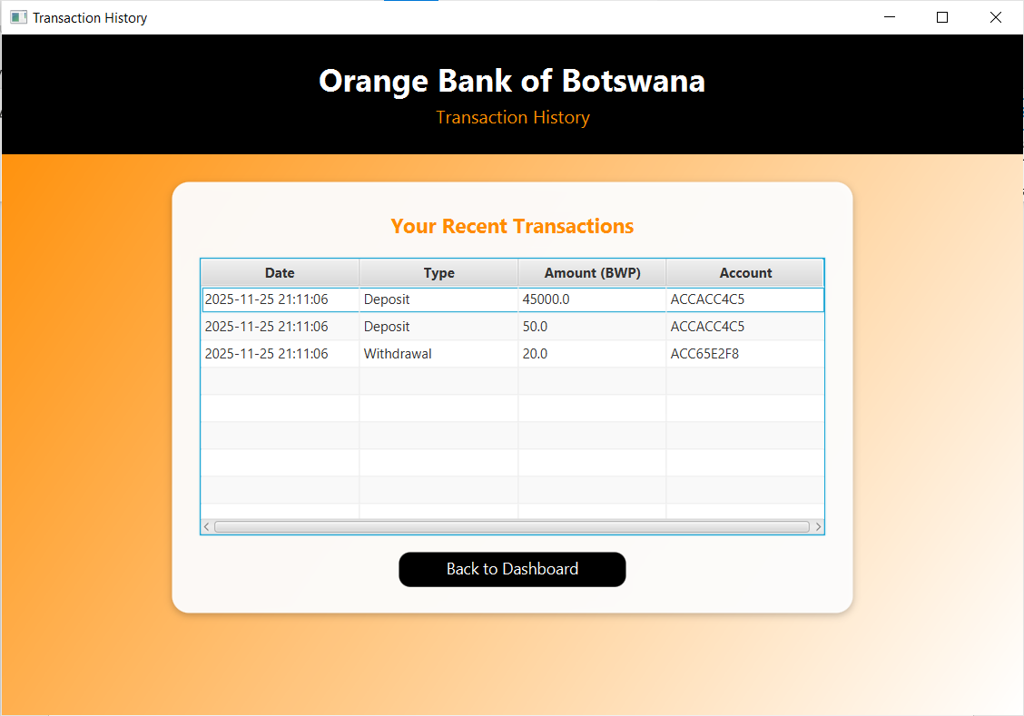
- Investment – Explore and manage investment options.
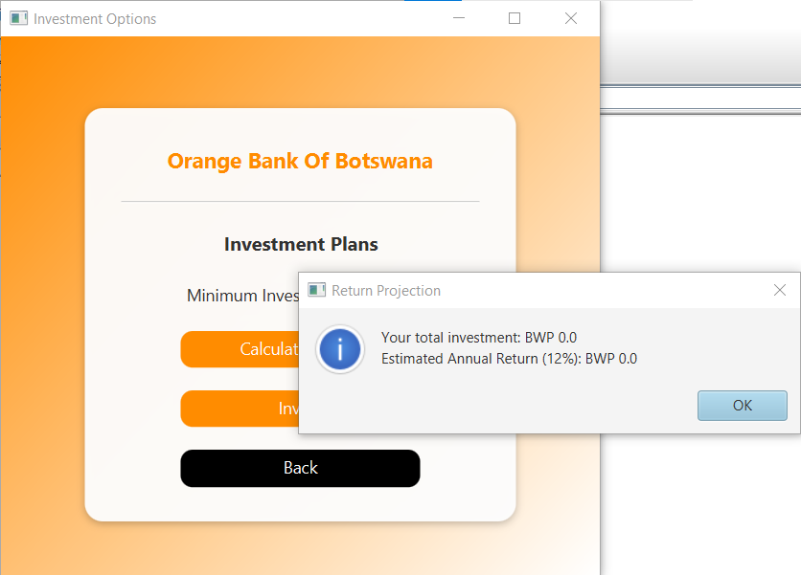
- Apply Interest – Use tools related to interest calculations or interest-based products.
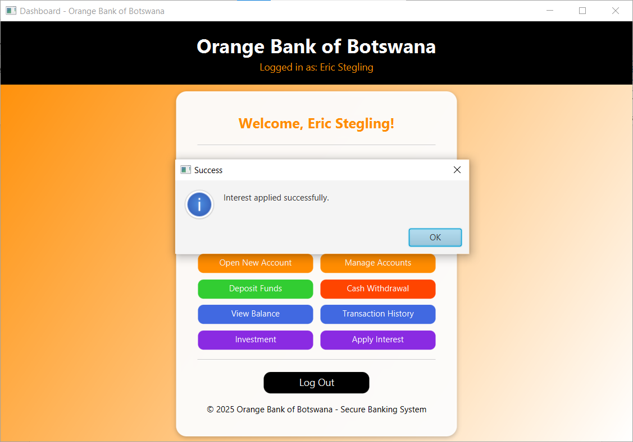

4. Security and Usability
- Easy Navigation: The simple list format makes it easy for users to find what they need.
- Log Out Button: Clearly shown at the bottom to help users end their session safely.
- Professional Footer: The footer text (“© 2025 Orange Bank of Botswana - Secure Banking System”) reinforces trust and professionalism.

5. Conclusion
The Orange Bank of Botswana user dashboard turns complex banking tasks into a smooth, easy to use digital experience. By showing key account information upfront and offering quick access to essential services from deposits to investments, the dashboard empowers users like Eric Stegling and reflects the bank’s dedication to modern, user-friendly online banking.

